PMI AUSTRALIA CONFERENCE

PMI Australia Awards
Nominations for the 2019 PMI Australia Awards are OPEN.
The Project Management Institute Australia Conference Awards provide the opportunity for practitioners to appreciate and recognise the achievements of organisations, projects and individuals in the field of project management.
If you know of anyone who deserves a nomination visit the PMI Australia Conference website for more information about the categories and nomination process.
More information

Speaker Announcements

Sally Foley-Lewis | Dynamic and interactive accredited professional speaker | Productive leadership | Author | Master your skills and achieve results in your career, business and life. Read more.

Glenn Smyth | Director and Principal architect at Fragile to Agile | 30 years in the IT industry | Specialist in SOA architectures and Business Transformation. Read more.

Marie-Claire Ross | Workplace sociologist | Speaker | Author | Focused on helping organisations create an environment where people can rely on each other more to work on the right things | Fellow of The CEO Institute. Read more.

Andrew Walters | Project Delivery Capability and Community Lead within Chief Project Office at Telstra | Focus on Capability Development in the Freight Forwarding and Telecommunication Industries. Read more.

Speak at PMI Australia Conference
We are still on the lookout for high quality speakers for our PMI Australia Conference 2019 Program!
Think you have what it takes? Read more about what we are looking for.
The next round of speakers is set to be decided soon!
SUBMIT PAPER

Tickets on Sale!
~Season’s Greetings~
TWENTY DAY SALE from 17th December – 5th January
Purchase a full conference ticket (2 day pass + dinner) and be in the draw to win an exclusive pass to the Executive Breakfast – 5 passes to be won!
Avoid the ticket price increase in the New Year!

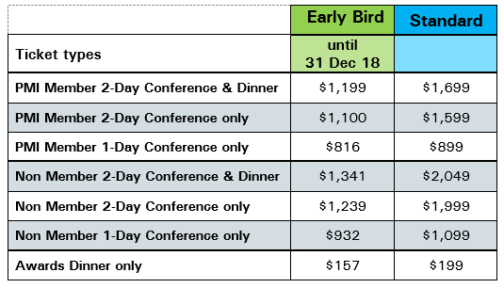

BUY NOW
NEED HELP CONVINCING YOUR BOSS?
Use our Letter to your Manager template which outlines all the important reasons you need to attend PMI Australia Conference 2019!

Partnership and Exhibition Opportunities
What did 2018’s Sponsors have to say?
“Congrats again on a fantastic conference! As sponsors, we felt well looked after over the course of the 2 days Looking forward to our continued work with you!”
“I’d just like to say CONGRATULATIONS on a very well planned and executed event! Thank you so much for all your assistance, it’s been an absolute pleasure working with you both”
The PMI Australia Conference 2019 provides an ideal platform to network and connect with a highly targeted and engaged audience.
So don’t delay – get in touch today to see how you can take your business to the next level and partner with PMI Australia Conference.
Contact our Project Management Institute of Australia Conference Directors – National Partners, Marketing & Innovation.
READ MORE OR CONTACT:
Geoff Close
+61 431 702 314
geoff.close@pmiaustraliaconference.org.au
David Close
+61 412 090 591
david.close@pmiaustraliaconference.org.au
